**Video rental system**

1. Adding Customers:

* *Add a customer and check if it adds to the database and shows in the data-grid*
* *The system should not store a blank customer name*

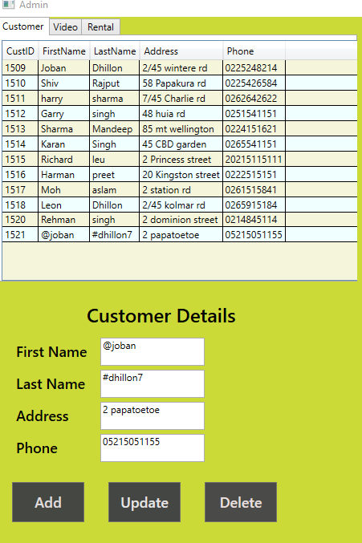

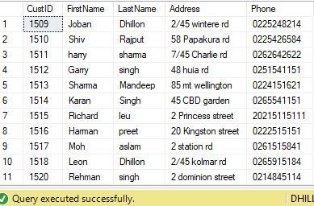

1. Adding Movies :

* *Add a Movie and check if it adds to the database and shows in the Data-grid*
* *The system should not store a Blank Movie*
* *Movie Genre should have proper value*

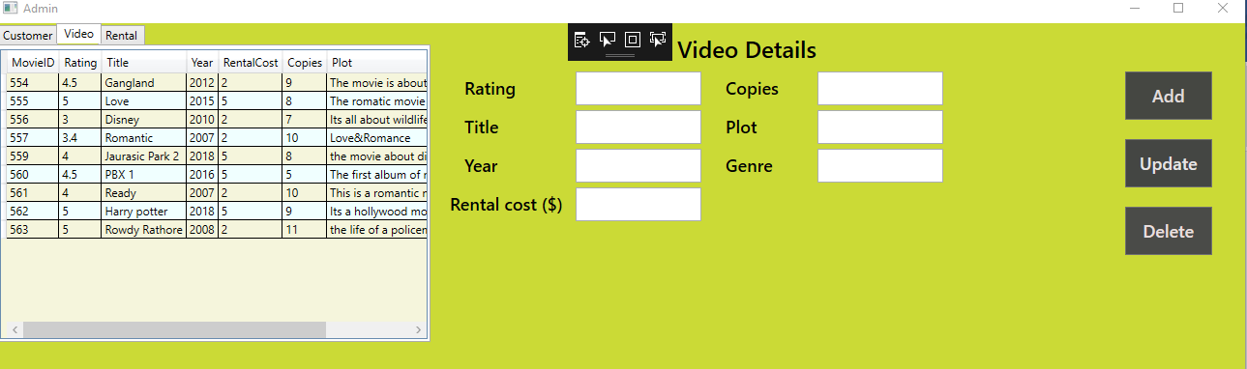

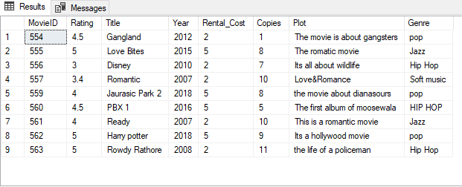

3.Popular Movie/Best Customer

* *By clicking on movie rate button, we can check the most rented movie name and its ID.*
* By clicking on Customer rate button, we can check the customer name who takes maximum movies on rent.

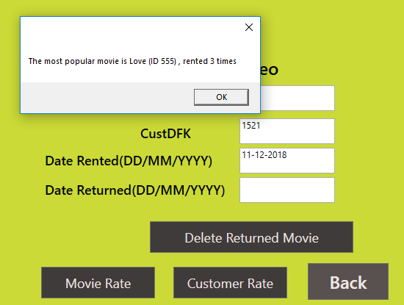

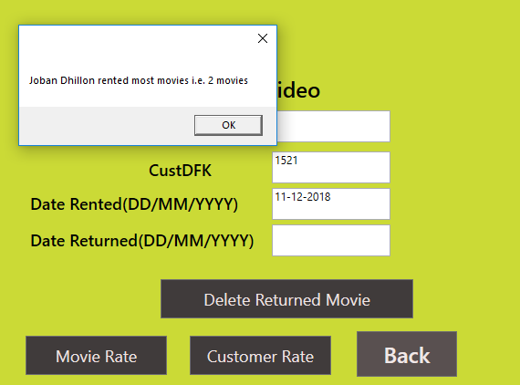

1. Update Movie/Customer :

* *Should update details of the respective movie and customer only.*

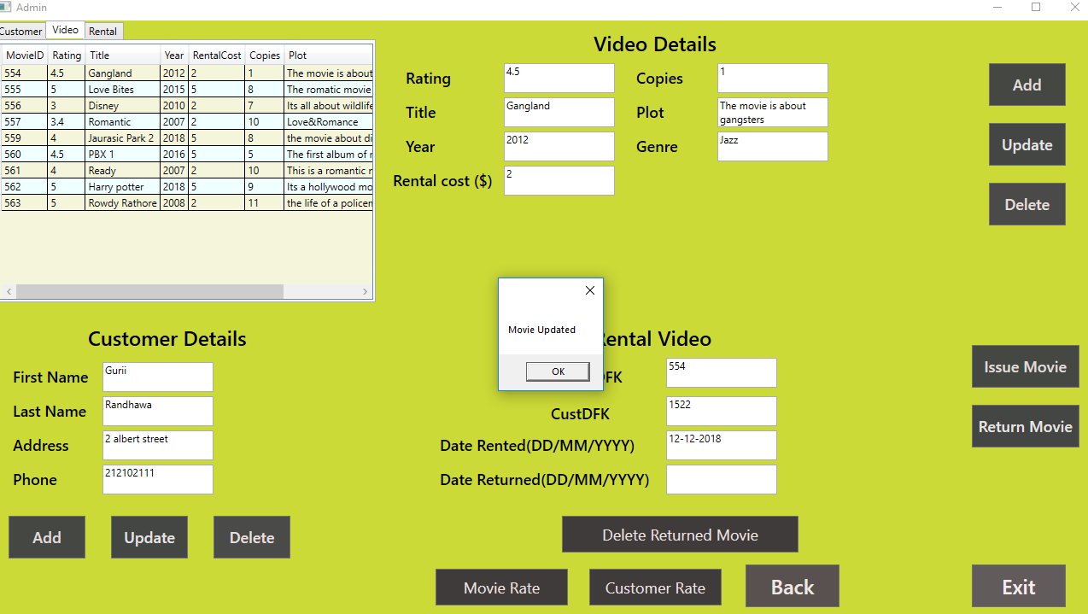

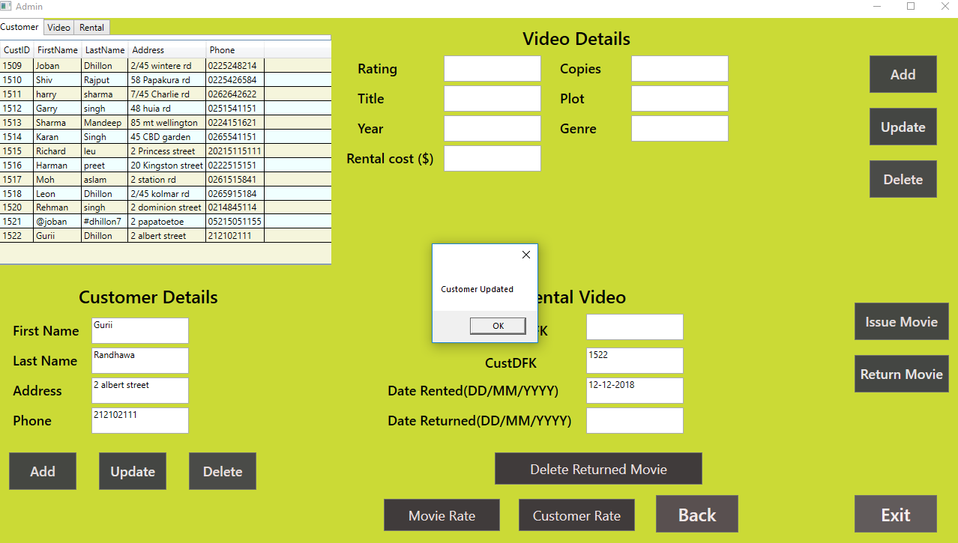

1. Delete Movie :

* *Should not be able to delete a movie that is rented out*

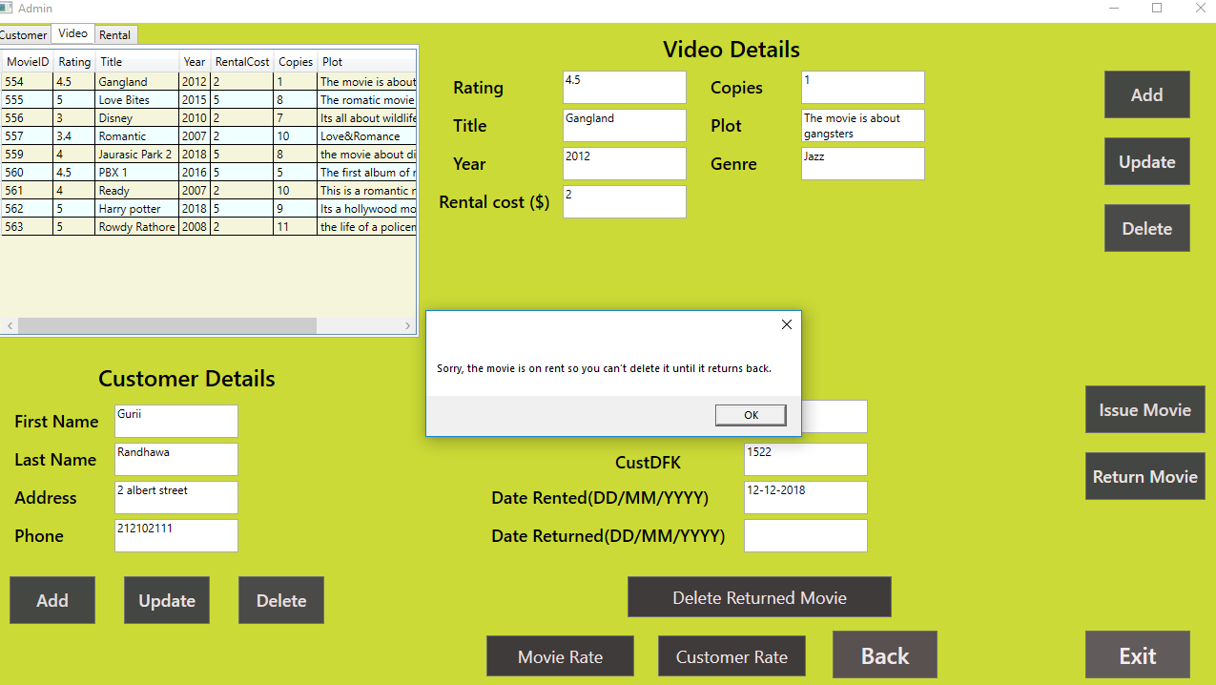

1. Delete Customer :

* *Should not be able to delete a customer that has rented out a movie*

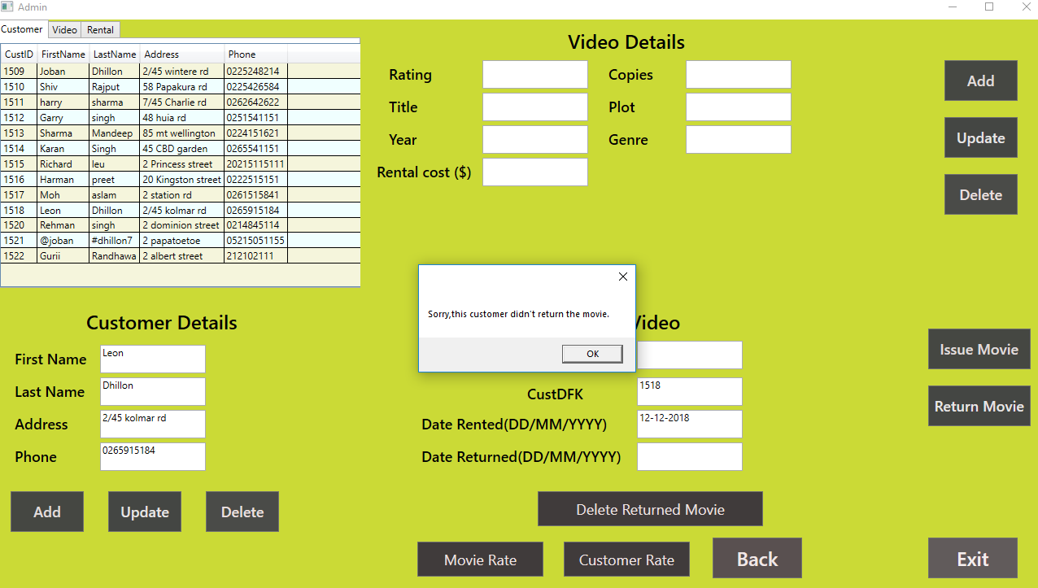

1. Issue Movie :

* *Issue a movie to a customer and check if it adds a record in the Rented movies table, Date rented should be the current system date*
* *System should not issue a movie that is already been rented out*
* *Give an error message if there are no copies of the movies*
* *Cannot issue more than two movies to the same customer*

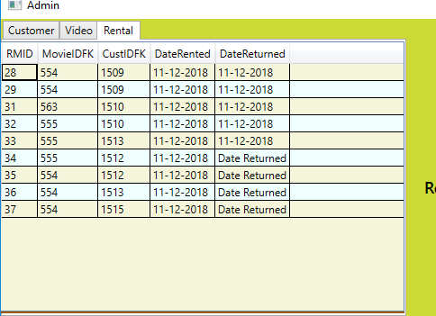

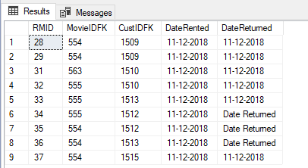

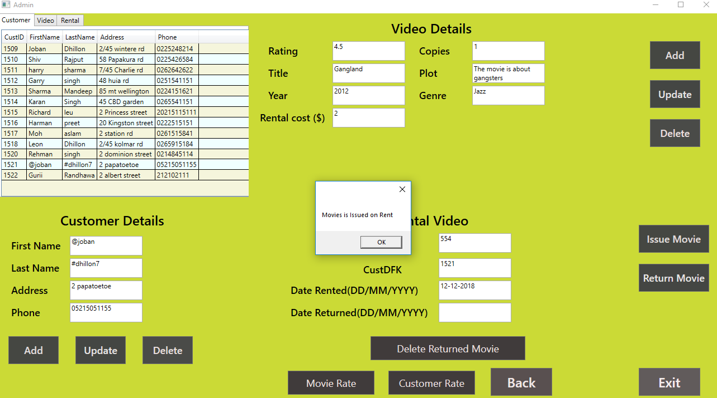

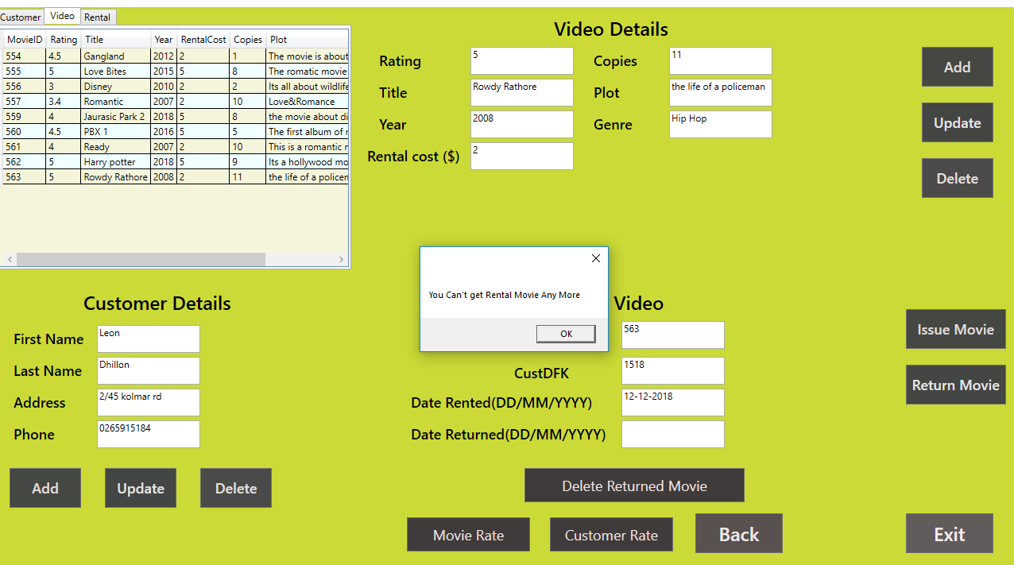

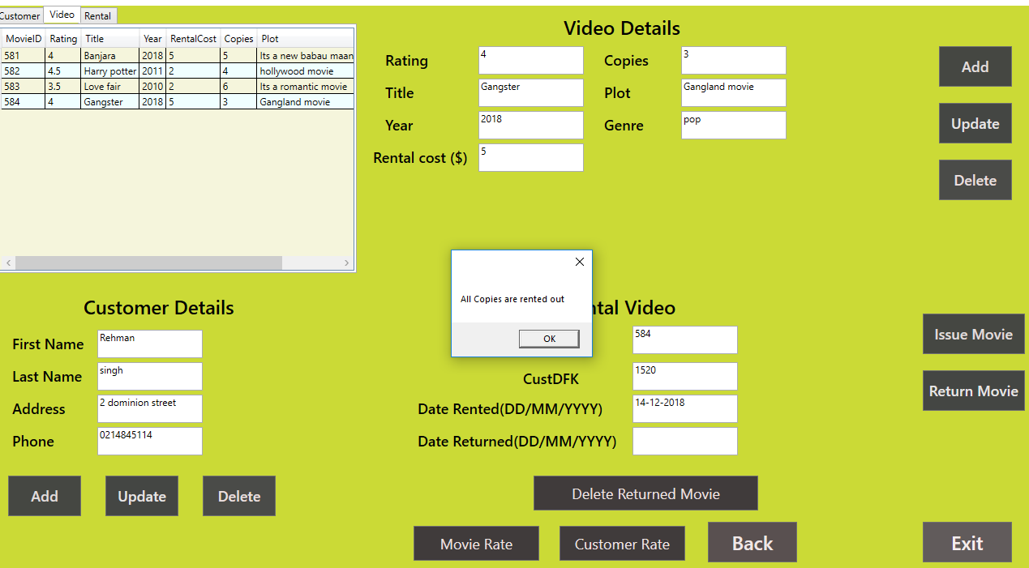

1. Return Movie :

* *Return movie should update the Rented Movies Table*
* *Date returned should reflect the current system date in the Rented movies table.*
* *The popup message will show the rented cost when you return the movie.*

